Process Design Document – Computer Vision

**UiPath Automation**

**Process Design Document**

**Process Design Document History**

|  |  |  |  |  |  |  |
| --- | --- | --- | --- | --- | --- | --- |
| **Date** | **Version Role** | | **Name** | **Organization** | **Function** | **Comments** |
| 09.01.2021 | 1.0 | Draft | Shylaja,  Julie,  Amita | HSI | Analyst + Developer | Creation v 1.0 |
|  |  | Reviewer | Nisha  Vrinda | HSI | BA | Approval pending lv 1.0 |

### Table of Contents

1. Introduction 3

Purpose of the document 3

Objectives 3

* 1. Process key contacts 3

1. AS IS Process Description 4
   1. Process overview 4
   2. Detailed Process map 6
   3. Detailed Process Steps 7
   4. Exceptions handling 9
   5. Error mapping and handling 10
   6. In-Scope application details 11
2. Development details 11
   1. Prerequisites for development 11
   2. Password policies 11
   3. Credentials and asset management 11
3. Document Approval Flow 12
4. Appendix 12
   1. UiPATH automated process details 12

# Introduction

## Purpose of the document

The Process Design Document describes the business processes chosen for automation using the UiPath Robotic Process Automation (RPA) technology.

This document describes the sequence of steps performed as part of the process, as well as the conditions and requirements prior to its automation. This design document serves as a base documentation for developers to collect the details required for robotic automation of the same business process.

## Objectives

## 

The process has been selected for RPA as Project Work for HSI.

The objective of this process automation is mainly to automate the process to

* Connect easily to a remote machine
* Access and store data to local machine.

## Process key contacts

The Design Document includes a brief, but comprehensive set of requirements for the process.

|  |  |  |  |
| --- | --- | --- | --- |
| **Role** | **Name** | **Date of action** | **Notes** |
| Reviewer | Nisha, Vrinda | TBD |  |
| Owner | Julie, Shylaja, Amita | TBD |  |
| Approval for production | Nisha , Vrinda | TBD | Escalations, Delays |

# AS IS Process Description

## Process overview

General information about the process selected for RPA implementation, prior to its automation:

|  |  |
| --- | --- |
| **AS IS process details** | |
| Process full name | Computer Vision for Remote Connection |
| Function | Remote Access |
| Department | IT |
| Process short description (operation, activity,  outcome) | Connecting to remote machine to access data and storing to local machine. |
| Role required for performing the process | 1 User , 2 systems |
| Process schedule | As and when required |
| # of item processes / day | NA |
| Average handling time per item |  |
| Peak period (s) | No peak period |
| # of FTEs supporting this activity | 3 |
| Level of exception rate | Remote system locked or no internet connection |

|  |  |
| --- | --- |
| Input data | Client Request |
| Output data | Data scrapped from remote machine |

* + 1. **In scope for RPA**

The activities and exceptions in this process that are in the scope for RPA, are listed below:

* + - * Full Scope for RPA- the process is to be 100%automated.
      * Connecting to remote machine.
      * Opening an application or website and perform actions and then getting the data to local machine.
    1. **Out of scope for RPA**

Data Encryption and decryption during data processing.

* 1. **Detailed Process map**

This chapter presents the chosen process in detail, which enables the developer to build the automated process.

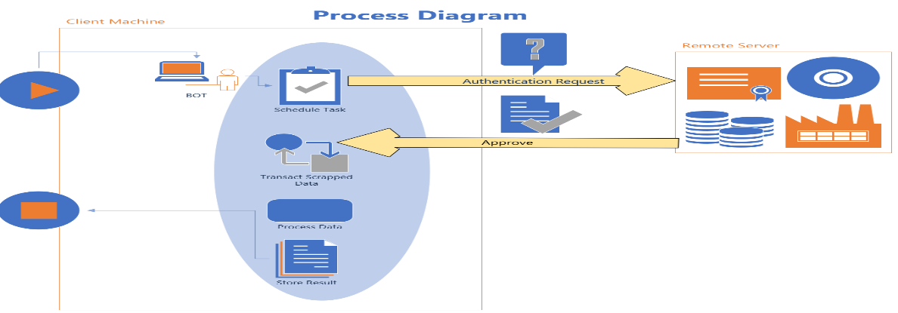

|  |  |
| --- | --- |
|  | |
| **1.1** | Start Process to Connect to Remote Machine |
| **1.2** | Enter Website name |
| **1.3** | Scrap data |
| **1.4** | Display data on Local Machine |
| **1.5** | Close connection |
| **1.5.A** |  |
| **1.5.B** |  |
| **1.5.C** |  |
| **1.5.D** |  |
| **1.5.E** |  |
| **1.6** |  |

## Detailed Process Steps

The complete set of steps in the process, including keystrokes and clicks, are to be deﬁned with screenshots. If there are any data restrictions, mask the sensitive information, such as Policy Number, Customer ID, bank account number, etc).

|  |  |  |  |  |
| --- | --- | --- | --- | --- |
| *#* | **Step action**  **description** | **Screenshot** | **Expected**  **result** | **Remarks** |
| 1.1 |  |  |  |  |
| 1.2 |  |  |  |  |
| 1.3 |  |  |  |  |
| 1.4 |  |  |  |  |

|  |  |  |  |  |
| --- | --- | --- | --- | --- |
| **1.5** |  |  |  |  |
| **1.5.A** |  |  |  |  |
| **1.5.B** |  |  |  |  |
| **1.5.C** |  |  |  |  |

|  |  |  |  |  |
| --- | --- | --- | --- | --- |
| **1.5.E** |  |  |  |  |
| **1.5.F** |  |  |  |  |
| **1.6** |  |  |  |  |

## Exceptions handling

The types of exceptions identifiable in the automation process can be classified according to the table below.



|  |  |  |
| --- | --- | --- |
| **Area** | **Known** | **Unknown** |
| **Business** | Previously encountered situation. A possible scenario is defined, and clear actions and workarounds are provided for each case. | A situation never encountered before. It can be caused by external factors. |

Based on the above criteria, the table below should reflect all the known exceptionsidentified throughout the process and map the expected action the robot needs to take in each case.

Insertas manyrowsas requiredin the table,to captureall exceptionsin a comprehensivelist.



|  |  |  |  |  |
| --- | --- | --- | --- | --- |
| **#** | **Exception name** | **Step where**  **exception is encountered** | **Parameters** | **Action to be taken** |
| **1** |  |  |  |  |
| **2** |  |  |  |  |

## Error mapping and handling

A comprehensivel ist of all the errors, warnings, or notifications should be consolidated here with the description and action to be taken by the Robot in each case.

The errors identifiedin the automationprocess can be classifiedaccording to the tablebelow.



|  |  |  |
| --- | --- | --- |
| **Area** | **Known** | **Unknown** |
| **Technology** | Previously encountered situation - action plan or  workaround available. | A situation never encountered before, or may happened independent of the applications  used in the process. |

Based on the above criteria, the table below should reflect all the identifiable errors in the process, and map the expected action of the Robot in each case.



Insert as many rows as required in the table, to capture all the errors in a comprehensive list.

|  |  |  |  |  |
| --- | --- | --- | --- | --- |
| **E #** | **Error Name** | **Step where**  **error is encountered** | **Parameters** | **Action to be taken** |
| **1** | Application unresponsive/ page not  loading | Any step | No response/ blank page | Retry2 times.  Close applicationand run the sequence again |

*Feel freeto insertan additionalerror mappingtable formore completeexplanation.

## In-Scope application details

The table below lists all the applicationsthat are used as part of the automatedprocess.

|  |  |  |  |  |  |  |
| --- | --- | --- | --- | --- | --- | --- |
| **#** | **Application name &**  **Version** | **Syst. Lang.** | **Login module** | **Interface** | **Environment/ Access method** | **Comments** |
| 1 | Computer Vision | EN | Web | Web | Web Browser |  |

# Development details

## Prerequisites for development

� Development or testing environment are to be provided for development purposes.

� The provided development and testing environments are exact replicas of the production environment.

� Dedicated system and application access are given to developers with the adequate permissions.

## Password policies

Users manage their own passwords. There are no special policies in place.

## Credentials and asset management

Login details (user IDs and passwords) should be stored under **Windows Credential Manager** or

#### UiPath Orchestrator Assets.

1. **Document Approval Fl**

|  |  |  |  |  |  |
| --- | --- | --- | --- | --- | --- |
| **Version** | **Flow** | **Role** | **Name** | **Organization (Dept.)** | **Signature and Date:** |
| **1.0** | Document preparedby | Business Analyst | Name Surname |  |  |
| **1.0** | Document Approved by: | Business Process Owner | Name Surname |  |  |
| **1.0** | Document Approved by: | Dev/RPA Solution Architect | Name Surname |  |  |

# Appendix

## UiPath automated process details

**Note: this step is to be ﬁlled in after automation process is complete**

**Automation overview**: (time to dev, test, etc)

**Robots type**: Back Oﬃce Robot

#### Level of human intervention required:

#### Use of Orchestrator:

#### Exceptions recorded in automation process: Errors identiﬁed in the automation process:

#### Challenges identiﬁed in the automation process:

#### Lessons Learned:

**Any adjustments** made to facilitate the automation process and any steps taken to shift from the human way of working to the automatic one. Any activityperformed to improve the As Is process and to enable higher rates of automation of the process:

* Process Assumption
* Input data assumption
* Number or types of inputto be received
* Skipping thelogin interfaceand collectingbackend details
* Extractingbackend data withoutopening the file
* Data conversion/ formatting

**Reporting:** The detailsand formatof the loggingmechanismavailable inthe workflowhave to be specifiedhere, whetherit is a local logreportor the Orchestratorlog).

The formatshould be specifiedby the business users.

**Workflow and scripts:** A brief overview of each workflowand the sequence in which it is executed should be providedhere.